|  |  |
| --- | --- |
|  | **Narrogin Senior High School**  **2024 – Mathematics Methods Year 11**    Total: **/44 marks** |

**Calculator Fee / 12 marks**

1. [1, 1, 1 marks]

Use the unit circle shown to determine the following, giving your answers in terms of *a*, *b*, *c*, and *d*.

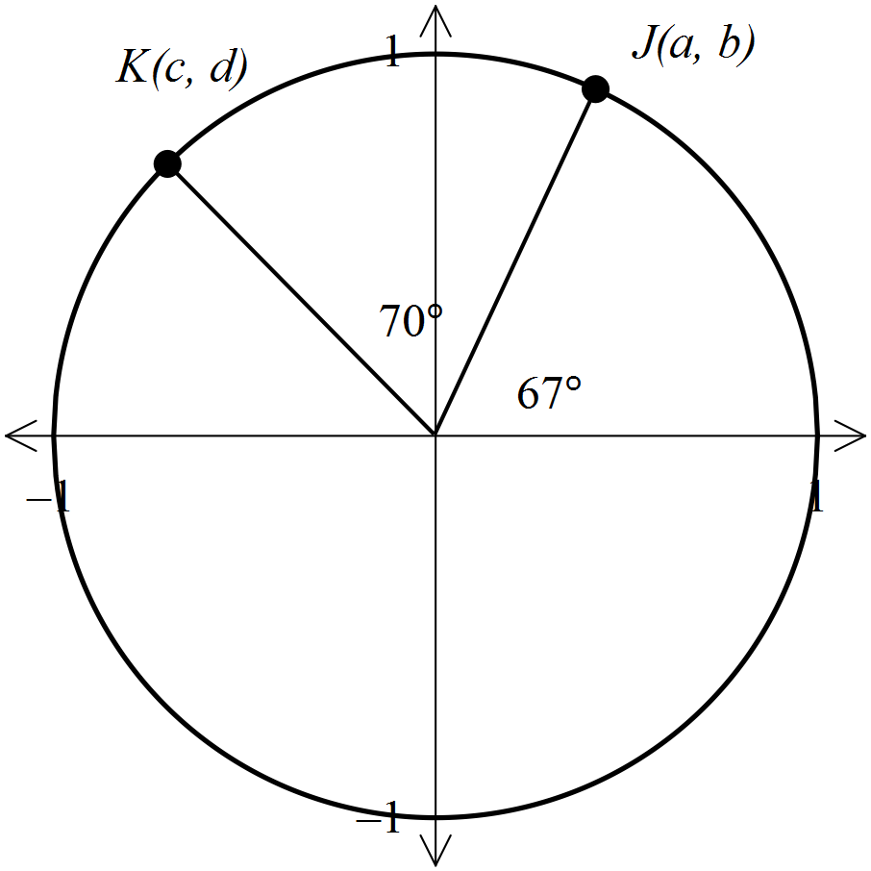

e.g. sin 67° = *b*

* 1. cos 137°
  2. sin 43°
  3. cos 223°

2. [1, 1 mark]

Write the following angles in radians.

a) 30° b) 120°

3. [1, 1 marks]

Write the following angles in degrees.

1. 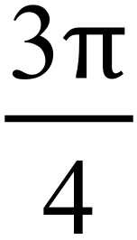 b) 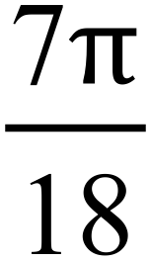

4. [3 marks]

Determine the value of cos A in the following triangle.

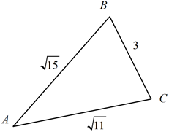

5. [2 marks]

Simplify 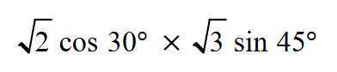

**Calculator Assumed /32**

6. [2, 3, 3: 8 marks]

* 1. Determine the value of *x*.

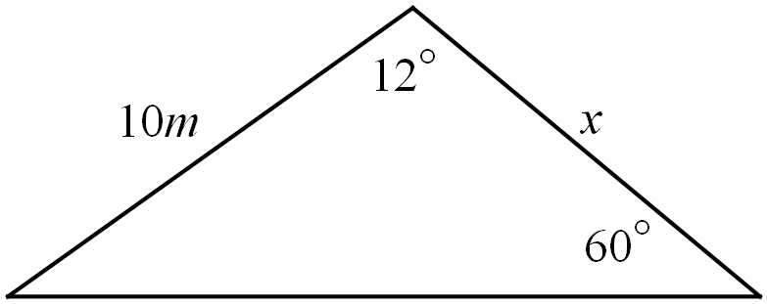

* 1. Calculate the size of the angle marked *x*.

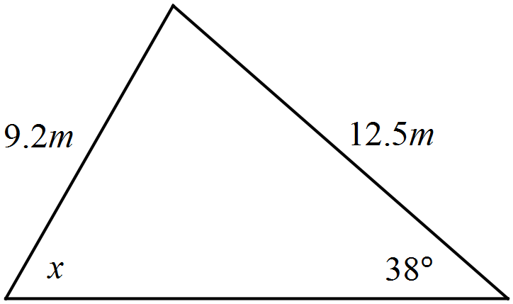

* 1. If the triangle below has an area of  cm2, determine the value of *x*.

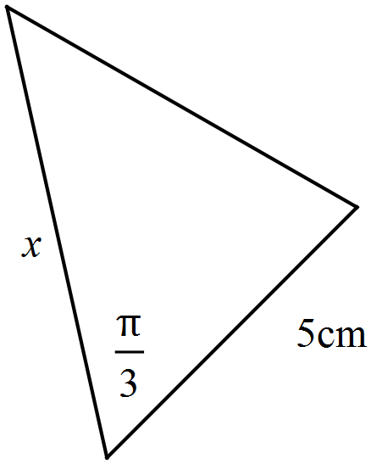

7. [3 marks]

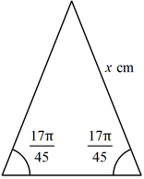The triangle below has an area of 35 cm2. How long is the side marked x?

8. [4 marks]

An air-traffic controller has two planes on his radar, an Airbus and a Boeing. The Airbus is 18.6 km away on a bearing of 080°, a Boeing is 32.4 km away on a bearing of 140°. What is the distance and bearing of the Airbus from the Boeing?

9. [1, 2, 2, 2: 7marks]

Triangle WXY has an **obtuse** angle at X, w=45 cm, y=34 cm and an area of 739 cm2.

1. Sketch a triangle to show this information.

b) Find ∠X.

c) Find x.

d) Find ∠Y.

10. [ 1, 1, 3: 5 marks ]

In triangle *ABC*, *c* = 7.2cm, *a* = 8.4cm and ∠*B* = 61°.

1. Sketch a triangle to show this information.
2. If *Q* is the midpoint of *BC* and *R* is a point on *AB* such that *AR* = , draw a diagram, indicating clearly the lengths of the sides *AR, RB, BQ* and *QC.*

1. Calculate the area of the quadrilateral *ARQC*.

11. [5 marks]

Two circles of radius 12 cm, with centres A and B, and a third circle of radius and   
centre C, just touch each other, as shown below. Triangle ABC is right angled at C.

Given:  cm.

Determine the shaded area enclosed by the three circles, rounding your answer to one decimal place.

